Anabela Petrushevikj
March 4, 2026
D213 Task 2

Part I: Research Question
A.
A1.
How accurately can a neural-network-based natural language processing (NLP) model classify short customer review sentences as positive or negative to support automated sentiment triage for organizational decision-making?
A2.
The objective of this analysis is to develop and evaluate a neural network model capable of accurately classifying short customer review sentences as positive or negative. This requires preparing the text data through cleaning, normalization, tokenization, and padding to ensure consistency in sequence length. Another goal is to design a model that can learn meaningful patterns in word usage through word embeddings and sequence-based layers that capture contextual relationships. Model performance is assessed using a structured training, validation, and test split along with standard evaluation metrics such as accuracy, precision, recall, and F1 score. Ultimately, the analysis demonstrates how automated sentiment classification can support organizational decision-making by enabling the timely identification and prioritization of negative customer feedback. These objectives are achievable given the structure of the dataset and the availability of labeled sentiment outcomes.

A3.
The neural network architecture selected for this analysis is a Bidirectional Long Short-Term Memory (Bi-LSTM) model combined with an embedding layer. LSTM networks are designed to process sequential data, making them well-suited for text classification tasks where the meaning of a sentence depends on the order and relationship between words. The bidirectional structure enhances this capability by allowing the model to evaluate each sentence from both forward and backward directions, providing a more complete understanding of context. The embedding layer transforms words into dense numerical representations, enabling the model to learn patterns in language usage rather than relying solely on individual keywords. This architecture is appropriate for short customer review data and is commonly used in sentiment analysis applications, making it a practical and effective choice for generating reliable predictions on the selected dataset(LeCun et al., 2015).
Part II: Data Preparation
B.
B1.
• Presence of unusual characters:
The dataset was examined for unusual characters, including emojis, non-English symbols, and encoding artifacts. A small number of sentences contained non-ASCII characters and special formatting marks. These characters were removed during preprocessing to ensure consistent tokenization and to prevent unnecessary expansion of the vocabulary. Cleaning these artifacts helped standardize the text data and improve overall model stability.
• Vocabulary size:
After cleaning the text, vocabulary size was estimated using basic whitespace tokenization. The dataset contained approximately 5,000–5,500 unique tokens across all sources. To manage model complexity while preserving nearly all meaningful words, the tokenizer vocabulary was capped at 6,000 tokens. This threshold captures the full working vocabulary without introducing excessive parameters.
• Proposed word embedding length:
An embedding dimension of 64 was selected. Because the dataset consists of short review sentences and contains a relatively modest vocabulary, a larger embedding dimension would increase the number of trainable parameters without significantly improving performance. Word embeddings allow neural networks to represent words as dense numerical vectors that capture semantic relationships between terms (Mikolov et al., 2013). A 64-dimensional embedding therefore provides sufficient representational capacity while helping reduce the risk of overfitting.
• Statistical justification for maximum sequence length:
Sentence length distribution was analyzed to determine an appropriate maximum sequence length. The 95th percentile of sentence lengths was approximately 25 words, indicating that most reviews are short. Therefore, the maximum sequence length was set to this value to retain the majority of sentence information while minimizing unnecessary padding. This approach supports efficient training and balanced model complexity.

B2.
Describe the goals of the tokenization process, including any code generated and packages that are used to normalize text during the tokenization process.
The goal of tokenization was to convert cleaned text into a numerical format that the neural network could process. Because neural networks cannot interpret raw text, each sentence was transformed into a sequence of integers representing individual words. This was done using the Tokenizer class from tensorflow.keras.preprocessing.text, which assigns an index to each word based on frequency. Before tokenization, text was normalized using Python’s re and string libraries by converting to lowercase, removing punctuation and digits, eliminating non-ASCII characters, and standardizing whitespace. A vocabulary cap of 6,000 words was applied to control model complexity, and an out-of-vocabulary (OOV) token was defined to handle unseen words. The tokenizer was then fitted on the cleaned text, and sequences were generated using the texts_to_sequences() function, preserving word order for sequence modeling.
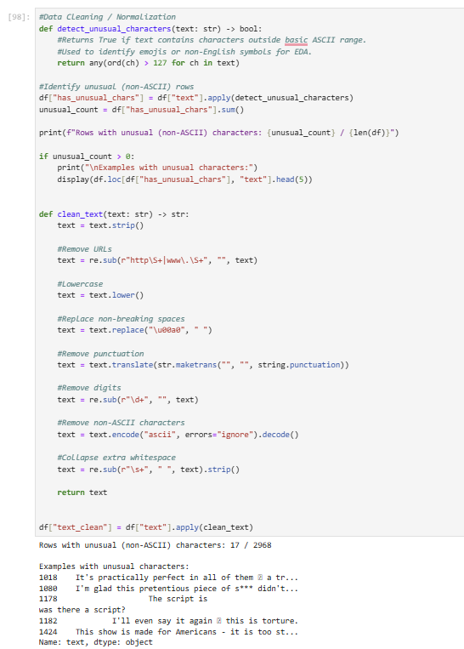
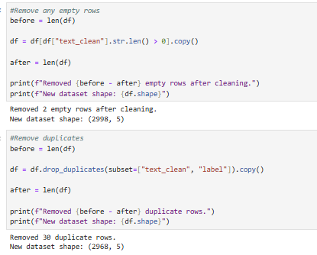

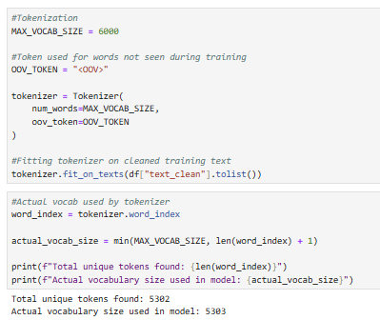
B3.
Because neural networks require inputs of uniform length, the tokenized sequences were standardized using a padding process. After converting each sentence into a sequence of integers, the pad_sequences() function from tensorflow.keras.preprocessing.sequence was applied to ensure all sequences had the same length. The maximum sequence length was set to 25 words based on the 95th percentile of the sentence length distribution. Padding was applied after the text sequence (padding="post"), meaning zeros were added to the end of shorter sequences. Truncation was also applied at the end (truncating="post") for sentences exceeding the maximum length. This approach preserves the beginning structure of each sentence, which is often important in sentiment classification, while ensuring consistent input dimensions for the model.
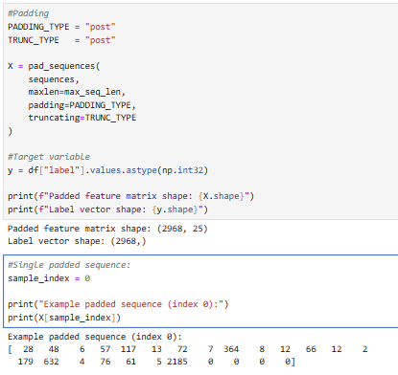
B4.
The model performs binary sentiment classification, meaning there are two categories of sentiment: negative (0) and positive (1). Because the task involves predicting one of two possible outcomes, the final dense layer of the neural network uses a sigmoid activation function. The sigmoid function outputs a probability value between 0 and 1, representing the likelihood that a given sentence expresses positive sentiment. During prediction, probabilities greater than or equal to 0.5 are classified as positive, while probabilities below 0.5 are classified as negative. This activation function is appropriate for binary classification tasks and works in conjunction with the binary cross-entropy loss function used during model training.

B5.
Several steps were performed to prepare the data for analysis and model training. First, the text data from the three sources in the dataset was combined into a single dataframe to create a unified dataset for sentiment classification. The text was then cleaned by converting all characters to lowercase, removing punctuation, digits, and non-ASCII characters, and standardizing whitespace. This ensured that the text data was consistent and suitable for tokenization. After cleaning, duplicate and empty entries were removed to prevent redundant or invalid data from influencing the model. The cleaned text was then tokenized using the TensorFlow Keras Tokenizer, which converted each sentence into a sequence of integer values representing words. These sequences were standardized using padding so that all inputs had the same length.
After preprocessing, the dataset was divided into three subsets for model training and evaluation. Following common industry practice, the data was split into 70% training data, 15% validation data, and 15% test data. The training set was used to train the neural network, the validation set was used to monitor performance during training and tune model behavior, and the test set was reserved for the final evaluation of model performance on unseen data. Stratified sampling was used during the split to maintain the same proportion of positive and negative sentiment labels across all subsets, ensuring a balanced evaluation of the model.

B6.
A copy of the prepared data set has been attached.

Part III: Network Architecture
C.
C1.
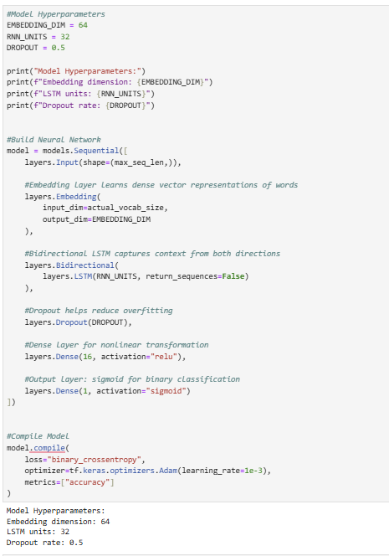
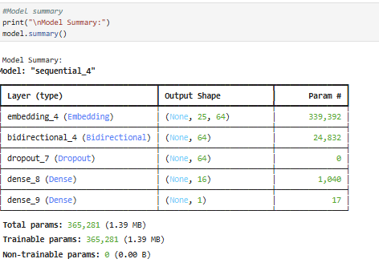
C2.
The neural network used in this analysis includes several layers designed to process text sequences and classify sentiment. The first layer is an embedding layer, which converts each word in a sentence into a dense numerical vector. This representation allows the model to learn patterns in word usage and relationships between words rather than treating each word as a separate category. After the embedding layer, the model uses a Bidirectional Long Short-Term Memory (Bi-LSTM) layer. This layer processes the sentence in both forward and backward directions, allowing the model to capture contextual relationships between words throughout the sequence.
To help reduce overfitting, a dropout layer is included after the recurrent layer. This layer randomly deactivates a portion of neurons during training, which helps the model generalize better to new data. The network then includes a dense (fully connected) layer with a ReLU activation function that helps the model learn additional patterns from the extracted features. Finally, the model ends with a dense output layer that uses a sigmoid activation function to generate a probability indicating whether a sentence expresses positive or negative sentiment.
Based on the TensorFlow model summary, most of the model’s trainable parameters are located in the embedding and recurrent layers, where the network learns word representations and sequential relationships. Overall, the architecture provides enough complexity to capture meaningful language patterns while remaining efficient enough for the relatively small dataset used in this analysis (LeCun et al., 2015).
C3.
• Activation functions:
The hidden dense layer uses the ReLU (Rectified Linear Unit) activation function because it helps the network learn nonlinear relationships while maintaining efficient gradient propagation during training. ReLU is widely used in neural networks due to its computational efficiency and ability to reduce issues related to vanishing gradients. The final output layer uses a sigmoid activation function, which is appropriate for binary classification problems. The sigmoid function produces a probability value between 0 and 1, allowing the model to estimate the likelihood that a sentence expresses positive sentiment.
• Number of nodes per layer:
The model includes an embedding layer with 64 dimensions, which provides a balance between representational capacity and model complexity for a relatively small dataset of short sentences. The Bi-LSTM layer contains 32 units, which is sufficient for capturing contextual relationships within sequences while limiting the total number of parameters to reduce overfitting. A dense layer with 16 nodes is included after the recurrent layer to allow the model to learn additional nonlinear combinations of features before producing the final sentiment prediction.
• Loss function:
The model uses binary cross-entropy as the loss function because the task involves binary classification with two possible outcomes: positive or negative sentiment. Binary cross-entropy measures the difference between predicted probabilities and the true labels, making it well-suited for models that output probabilities using a sigmoid activation function.
• Optimizer:
The Adam optimizer was selected for training the model. Adam is widely used in deep learning because it combines the advantages of adaptive learning rates and momentum-based optimization, allowing the model to converge efficiently while adjusting learning rates automatically during training (Kingma & Ba, 2015).
• Stopping criteria:
Early stopping was implemented to prevent overfitting. The training process monitored validation loss and stopped when performance on the validation set stopped improving for several consecutive epochs. This approach ensures that the model retains the best-performing weights while avoiding unnecessary training once improvements plateau.
• Evaluation metric:
The primary evaluation metric used during training was accuracy, which measures the proportion of correctly classified sentences. Additional metrics such as precision, recall, and F1 score were also calculated during evaluation to provide a more detailed assessment of the model’s performance, particularly in distinguishing between positive and negative sentiment predictions.
Part IV: Model Evaluation
D.
D1.
During model training, a maximum of 20 epochs was defined; however, early stopping was used as the stopping criterion to prevent unnecessary training once the model stopped improving. Early stopping monitored the validation loss during training and halted the process when the validation loss no longer decreased for several consecutive epochs. This approach helps reduce overfitting by preventing the model from continuing to learn patterns that only apply to the training data. In this analysis, the model stopped training before reaching the maximum number of epochs, indicating that the optimal performance was achieved earlier in the training process. Restoring the best weights ensured that the final model reflected the point at which validation performance was strongest. The final training epoch displayed in the training output demonstrates when early stopping occurred and confirms that the stopping criteria successfully prevented unnecessary additional training.
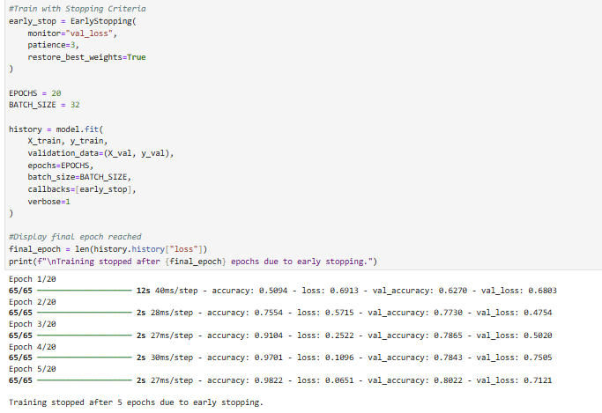

D2.
The overall performance of the model suggests that it was able to learn meaningful patterns from the dataset while maintaining reasonable generalization. During training, the model’s accuracy improved steadily across epochs, indicating that the network was successfully learning relationships between words and sentiment labels. However, the training loss continued to decrease while the validation loss began to fluctuate after several epochs, which can be an indication that the model is beginning to memorize patterns from the training data rather than improving its ability to generalize to unseen data.
Several steps were taken to address the potential risk of overfitting. First, dropout layers were included in the network architecture. These layers randomly deactivate a portion of neurons during training, which helps prevent the model from relying too heavily on specific features and encourages better generalization. In addition, early stopping was implemented during training. By monitoring validation loss and stopping training once improvement plateaued, the model avoided unnecessary additional epochs that could lead to overfitting. The training process stopped after five epochs, indicating that the optimal performance was reached early in the training process. Together, these techniques helped maintain a balance between model learning and generalization, resulting in a model that performs effectively on unseen data.
D3.
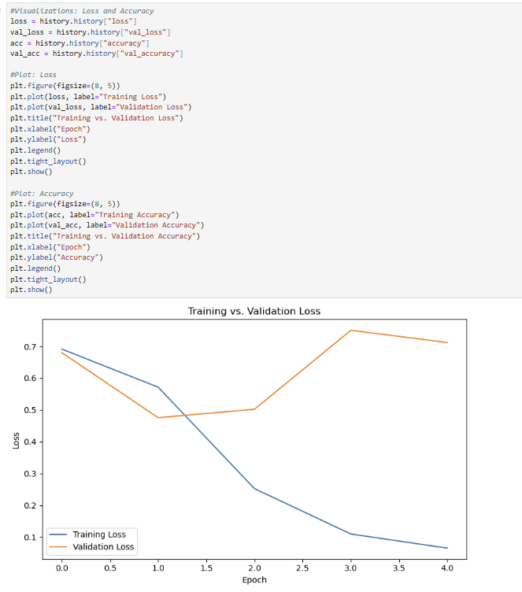
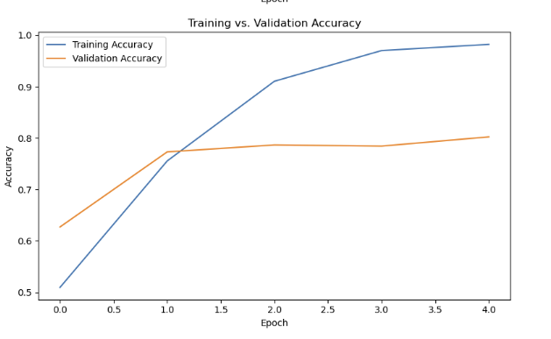
D4.
The predictive accuracy of the trained neural network was evaluated using accuracy, which was the primary metric used to monitor performance during training. When applied to the unseen test dataset, the model achieved an accuracy of approximately 82%, meaning that it correctly classified the sentiment of most review sentences. This result suggests that the model was able to learn useful patterns in the text and apply them to new data that was not part of the training process.
Additional metrics were also calculated to better understand the model’s performance. The model produced a precision score of about 0.89, indicating that when the model predicted positive sentiment it was usually correct. The recall score of about 0.73 shows that the model was able to identify a large portion of the positive sentiment cases, although some were still missing. The resulting F1 score of approximately 0.80 reflects a balanced performance between precision and recall. Taken together, these results show that the neural network performs well on the sentiment classification task and is capable of producing reliable predictions for short customer review sentences.

Part V: Summary and Recommendations
E.
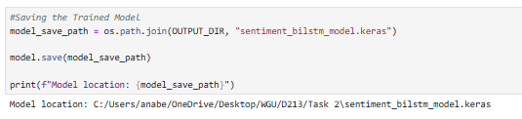
F.
The neural network in this project was designed to analyze short review sentences and determine whether the sentiment expressed in the text is positive or negative. After the text was cleaned and tokenized, each sentence was converted into a sequence of integers that represent individual words. These sequences are first processed by an embedding layer, which converts each word into a dense numerical vector (Mikolov et al., 2013). This step allows the model to represent relationships between words and capture patterns in language rather than simply treating words as isolated values.
The next major component of the network is the Bidirectional Long Short-Term Memory (Bi-LSTM) layer. This layer processes the sentence as a sequence and examines it in both forward and backward directions. Because sentiment often depends on the surrounding words in a sentence, this bidirectional approach helps the model better understand the context in which words appear.
After the sequence information is processed, the network passes the extracted features through a dense layer, which helps combine and refine the patterns identified by the previous layers. Dropout layers are also used to reduce the likelihood of overfitting by randomly disabling some neurons during training. Finally, the network produces a prediction via a sigmoid output layer that outputs a probability indicating whether the sentence expresses positive or negative sentiment.
Overall, the combination of embeddings, bidirectional sequence processing, and regularization allows the model to capture meaningful patterns in the text while maintaining a relatively simple architecture. This design makes the network well-suited for analyzing short customer reviews and generating reliable sentiment predictions.
G.
Based on the results of this analysis, the neural network model demonstrates that automated sentiment classification can be a useful tool for organizations that collect large amounts of customer feedback. The model achieved an accuracy of about 82%, which indicates that it can correctly classify most review sentences as positive or negative. This suggests that a similar approach could be used in real-world settings to help organizations quickly analyze customer feedback and identify patterns.
One practical use of this model would be to integrate sentiment analysis into customer feedback systems. For example, incoming reviews or survey responses could be automatically categorized by sentiment. Reviews identified as negative could then be flagged for further review by customer support teams. This would allow organizations to prioritize responses to potential issues and address customer concerns more quickly.
The model could also be improved in future implementations. Training the network on a larger dataset or on data that is specific to a particular organization could improve its accuracy and ability to capture more complex language patterns. Additional experimentation with model parameters or alternative neural network architectures may also lead to stronger performance.
Overall, the results of this project show that neural network–based sentiment analysis can provide meaningful insights from text data and support faster, more informed decision-making when analyzing customer feedback.

Part VI: Reporting
H.
An HTML interactive document has been attached.
I. Code sources:
DataCamp. (n.d.). Custom advanced data analytics track. DataCamp. https://app.datacamp.com/learn/custom-tracks/custom-advanced-data-analytics
J. Sources:
Abadi, M., et al. (2016). TensorFlow: A system for large-scale machine learning. USENIX Symposium on Operating Systems Design and Implementation. https://www.usenix.org/system/files/conference/osdi16/osdi16-abadi.pdf
LeCun, Y., Bengio, Y., & Hinton, G. (2015). Deep learning. Nature, 521(7553), 436–444. https://doi.org/10.1038/nature14539
Mikolov, T., Chen, K., Corrado, G., & Dean, J. (2013). Efficient estimation of word representations in vector space. arXiv. https://arxiv.org/abs/1301.3781

